Project Design Phase-II
Data Flow Diagram & User Stories

Date | 01 July 2026
Team ID
Project Name | STOCK TRADING APP
Maximum Marks | 4 Marks

Data Flow Diagrams:
A Data Flow Diagram (DFD) represents how data flows through the Stock Trading App. It illustrates how users interact with the system, how requests are processed by the backend, and how data is stored and retrieved from the database. The DFD helps visualize the movement of information between different components of the application, including user authentication, stock transactions, portfolio management, and transaction history.

Example: (Simplified)

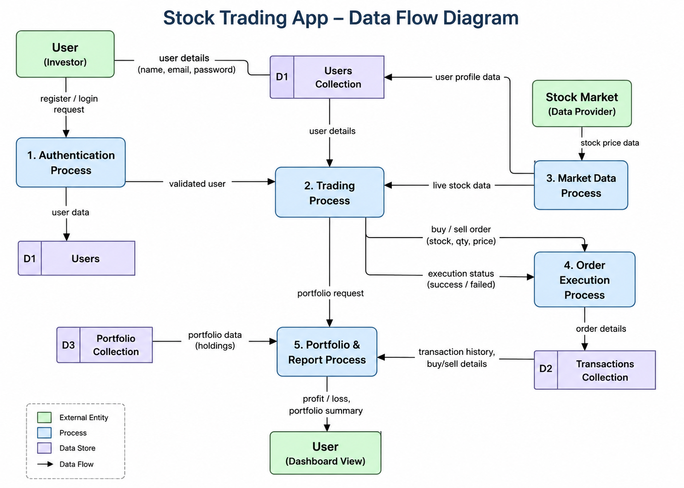

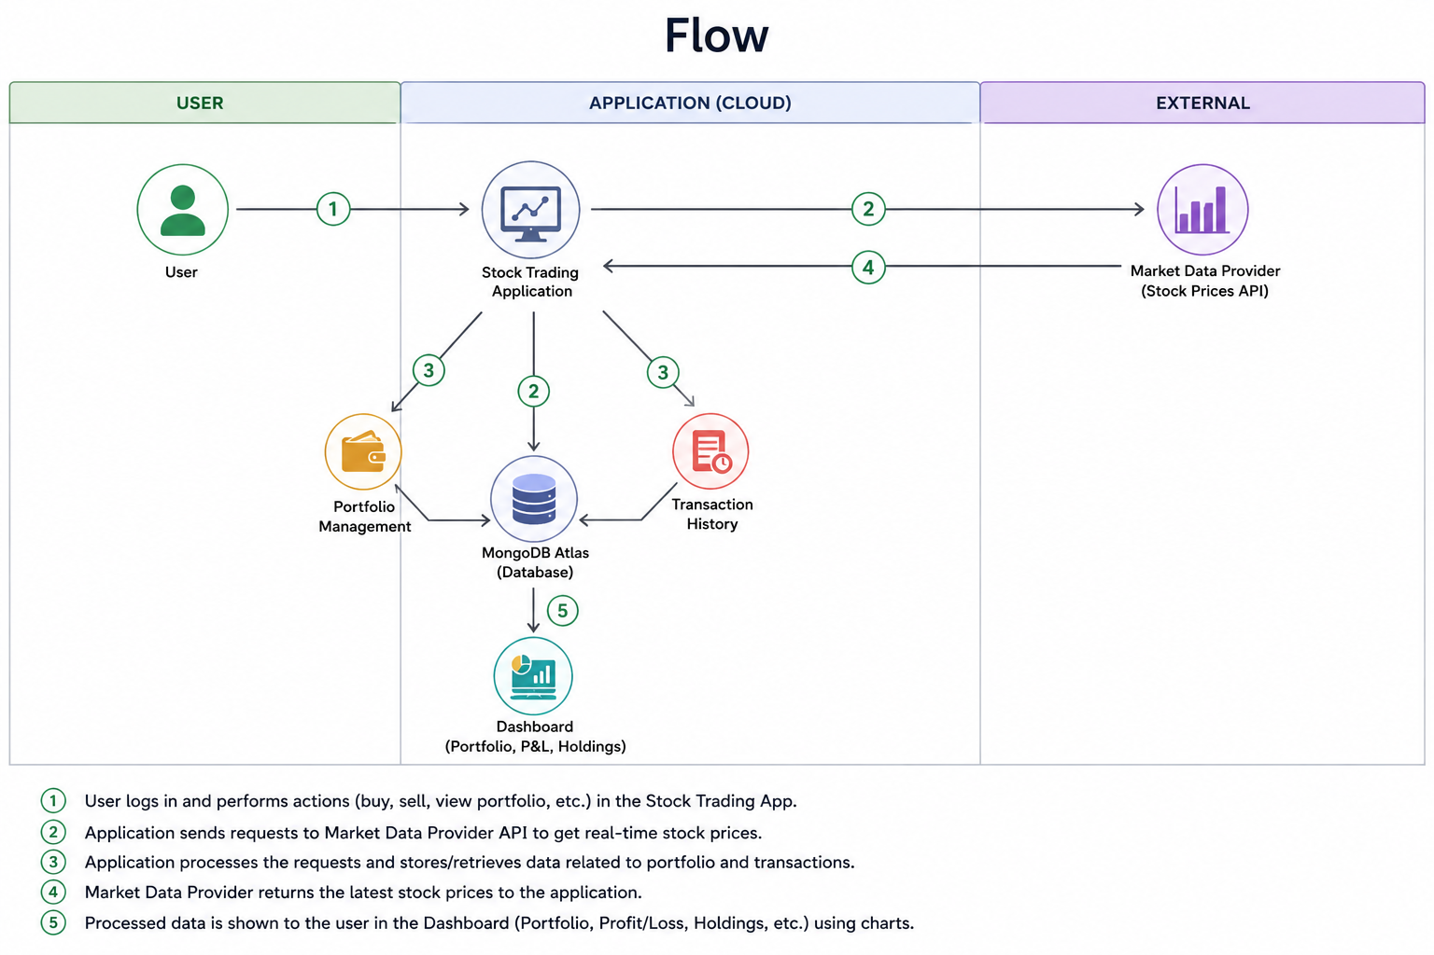

User Stories
Use the below template to list all the user stories for the product.
User Type | Functional Requirement (Epic) | User Story Number | User Story / Task | Acceptance criteria | Priority | Release
Customer (Web User) | Registration | USN-1 | As a user, I can register using my name, email, and password. | User account is created successfully. | High | Sprint-1
Customer (Web User) | Login | USN-2 | As a user, I can log in using my email and password. | User can access the dashboard after login. | High | Sprint-1
Customer (Web User) | Dashboard | USN-3 | As a user, I can view my stock trading dashboard. | Dashboard loads successfully after login | High | Sprint-2
Customer (Web User) | Buy Stock | USN-4 | As a user, I can buy stocks by entering the stock symbol, quantity, and price. | Stock is added to the portfolio and transaction history. | High | Sprint-2
Customer (Web User) | Sell Stock | USN-5 | As a user, I can sell stocks from my portfolio. | Stock quantity is updated and transaction is recorded. | High | Sprint-2
Customer (Web User) | Portfolio | USN-6 | As a user, I can view my current stock portfolio. | Portfolio displays stock symbol, quantity, and average buy price. | Medium | Sprint-3
Customer (Web User) | Transaction History | USN-7 | As a user, I can view my complete buy and sell transaction history. | All transactions are displayed correctly. | High | Sprint-3
Customer (Web User) | Profit/Loss Summary | USN-8 | As a user, I can view total investment, current value, and profit/loss | Summary cards display accurate values. | High | Sprint-3
Customer (Web User) | Logout | USN-9 | As a user, I can securely log out of the application. | User is redirected to the login page and session is cleared. | Medium | Sprint-3
Administrator | Database Management | USN-10 | As an administrator, I can manage user, portfolio, and transaction data. | Data is stored and maintained successfully. | Low | Sprint-4

